Behind the Scenes of the EARLI Research Stories Podcast
Dr. Stefan T. Siegel & Fabia Odermatt
Teaser:
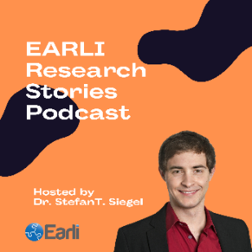
EARLI Research Stories – Your podcast uncovering stories from influential figures in the field of learning and instruction. What motivated them to become researchers? What are their next projects? And what advice do they have for young researchers of EARLI, the European Association for Research on Learning and Instruction. In this blogpost, we take you behind the scenes of the EARLI Research Stories Podcast. I explain the core idea and my motivations for bringing it to life and show you how an episode is produced – from concept to post-production.

- The Idea and the Format of the EARLI Research Story Podcast
The main aim of the EARLI Research Stories Podcast is to recognize the achievements of influential representatives of EARLI and the field of higher education and to interview them about their careers, their research, and their involvement with EARLI. With my fellow coordinators of the special interest group Higher Education (SIG 4), Helga Dorner and Rachelle Esterhazy, I started developing this podcast in 2022.
It was born was born out of my passion for higher education research and the desire to provide researchers just starting their academic journey with valuable insights and inspiration from experienced researchers. As I enjoy interacting with inspiring personalities, additionally, I wanted to learn how to create a podcast myself to capture their stories and perspectives.

- What has Happened so Far?
The EARLI Research Stories Podcast was launched in 2022 and aims to reach a broad educational audience, showcasing our members and their work as well as the important contribution education research can make to policy and practice. The first two guests were Sari Lindblom and Jan Vermunt. I led the interviews with them in February and April 2022 and I was fascinated by their reflections and insights. Unfortunately, the idea for this podcast was not born at that time. That is why these two episodes are not podcast episodes in the strict sense. However, you can find the transcripts of the interviews here and here. To start a podcast with written texts is rather unusual, however I felt that these belonged to this series. So far, I have produced the following 7 episodes in total:
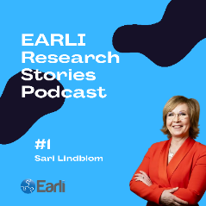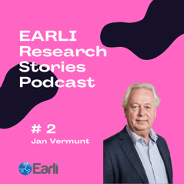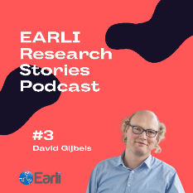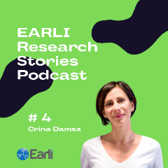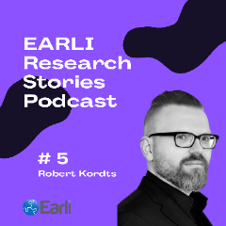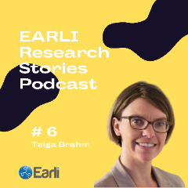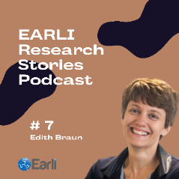
(Click on the pictures/covers to listen to the respective episode)

- Producing an Episode
Producing a podcast episode involves several steps. In the following, I would like to give you insights into how I usually did it.
Step 1: Guest Selection and Pre-Interview Preparation
The first step in producing an episode was to select a guest. My podcast typically features researchers in the field of learning and instruction who are members of EARLI. To find potential guests I brainstormed with my fellow SIG 4 coordinators on who has been a long-standing member of EARLI and who has an interesting story to share. Accordingly, we amongst others took a closer look at EARLI Oevre Award winners and winners of the Outstanding Publication Award which are linked to SIG 4. After identifying a guest, I reach out to them to explain the purpose and format of the podcast and to schedule a date.
To ensure a well-rounded and engaging conversation, I delve into the guest’s background, previous work, and current projects. This helped me to craft questions that spark insightful discussions and to write an outline for the interviews. For all episodes I used a guide, i.e., a set of similar questions. Before recording the podcast, I also had to find a suitable date and book the studio.
Step 2: Recording the Interview
With regard to the recording of the podcast episodes, I was fortunate and grateful to have the support of the Teaching Innovation Lab (TIL) at the University of St.Gallen (HSG). The TIL has set up a fully equipped podcast studio and supported me in the production. I would like to thank Fabia Odermatt, Media Lab specialist, for her professional support and patience.
To make sure that the audio quality is of a high standard I used the following equipment and the software Adobe Audition:
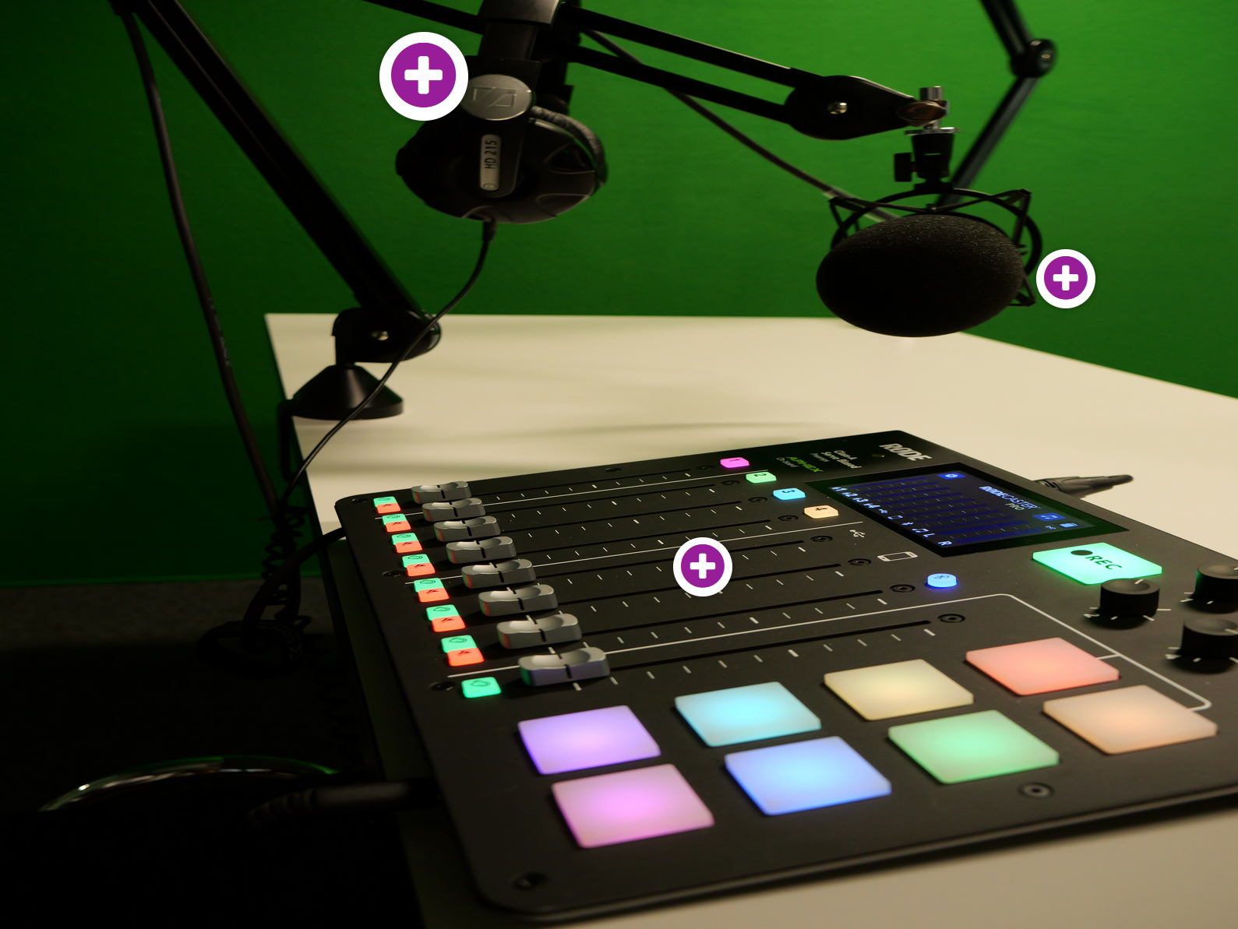
(Link to the interactive graphic)
During the interview I tried to speak slowly, clearly and to avoid for instance filler words. It is helpful, for example, to speak the introduction aloud to see if you stumble somewhere.
The interviews itself can last up to 60 minutes and can be conducted via video calls – especially if international guests are involved. In the case of the episode with Robert Kordts we recorded it live at a professional studio at media city Bergen.
In all interviews, my goal was to elicit interesting stories and insights that will be of interest to the podcast's audience.
Step 3: Post-production
Creating a high-quality podcast goes beyond just recording a great conversation; post-production plays a crucial role in refining the audio and ensuring a professional sound. After the recording session, the audio files are first edited for clarity and brevity.
To elevate the quality of your podcast you can apply different post-production techniques such as removing background noise, leveling your audio tracks, and using effects such as compression, normalization, or equalization. In this task the media lab supported me using again Adobe Audition. However, free, open source, cross-platform audio software such as Audacity or AudioMass, an open-source web based audio and waveform editing tool will work as well.
Step 4: Publishing your podcast /Marketing & Hosting
After completing the post-production phase of an episode, the final step involves publishing, marketing, and hosting to ensure that the podcast reaches my fellow EARLI researchers and gains traction.
Looking at different alternatives I decided to host and publish my podcast on the platform Captivate as the TIL has a subscription plan for it. Other free hosting platforms such as Buzzsprout or Podbean would have probably worked as well. Captivate allowed me to manage the podcast schedule, upload episodes and create show notes with helpful links, and contact information, and to create a website for the EARLI Research Stories Podcast. I created the art works (e.g., podcast cover) using Canva and listed the podcast in in leading directories including Apple Podcasts, Spotify, Google Podcasts.
To promote the podcast I worked together with Lisa Vanhaeren, EARLI Association Manager at the EARLI Office. Additionally, I used my own social media channels, e.g., Twitter or YouTube.

- Looking Back and Into the Future; What’s
Developing the EARLI Research Stories Podcast was and is a great learning project for myself. Creating a podcast like this takes, however, time and effort, so it’s important to consider ways to make the podcast more sustainable in the long run. To make the podcast more sustainable, to broaden it thematically, and foster a sense of community, we are exploring ways to involve junior researchers from various Special Interest Groups (SIGs) within EARLI:
This collaboration could take multiple forms, such as:
- Guest hosting: Junior researchers could host episodes, offering diverse perspectives and facilitating a wider range of conversations.
- Content curation: Junior researchers could suggest topics, guests, or even curate entire thematic series for the podcast.
- Production assistance: Involving junior researchers in different aspects of production, such as editing, social media management, or outreach, would help share the workload and create opportunities for skill development.
To further explore these and other options, together with Armin Weinberger, Jo van Herwegen, I will host a Workshop at the 27th JURE 2023 Pre-Conference at the Aristotle University of Thessaloniki (AUTh) in Thessaloniki, Greece.
Opening the doors to collaboration, could create a more inclusive, diverse, and sustainable podcast that reflects the rich tapestry of research interests within the EARLI community. Ultimately, my goal is to inspire and support the next generation of researchers, fostering a culture of curiosity, collaboration, and growth.
All in all, the EARLI Research Stories Podcast is an evolving platform dedicated to sharing the inspiring stories of researchers in learning and instruction. By offering a glimpse into the behind-the-scenes process, I hope to encourage more junior researchers to engage with and contribute to this project, helping it to thrive and grow within our community.
Helpful Resources to Explore
Albert, Virginia (2020). How to start podcasting. https://www.wissenschaftskommunikation.
de/how-to-start-podcasting-35309/
Katzenberger, V., Keil, J., & Wild, M. (Hrsg.). (2022). Podcasts: Perspektiven und Potenziale eines digitalen Mediums [Podcasts: Perspectives and potentials of a digital medium]. Springer. https://doi.org/10.1007/978-3-658-38712-9
Tobin, S. J., & Guadagno, R. E. (2022). Why people listen: Motivations and outcomes of podcast listening. PLOS ONE, 17(4), e0265806. https://doi.org/10.1371/journal.pone.0265806

Tags: #podcast #research #learning #instruction, #scicomm, #edresearch, #openscience, #phdchat #openscitalk #science #science #oer #educationalmedia #highered #sustainability #hsg

Authors
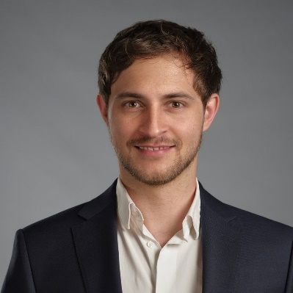 | 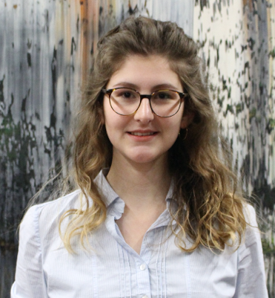
Dr. Stefan T. Siegel, postdoctoral researcher at the Institute for Business Education (IWP) at the University of St.Gallen. He is the author of several (inter)national articles and books and has several years of work experience in research and teaching in (high)school and non-school contexts. He has been awarded several prizes for his work. His current work focuses on educational theory, professionalization of teachers, educational media, science communication, science education, and sustainability.  stefan.siegel@unisg.ch  IWP-HSG | CEDAR | Fabia Odermatt, technical specialist at the Media Lab (TIL) at the University of St. Gallen who is passionate about creating engaging audio and video content for educational purposes. Besides her work at the Media Lab, Fabia also works with audio content in a different professional setting as she hosts the political segment at a youth and cultural radio station in Lucerne (3FACH).  fabia.odermatt@unisg.ch  TIL-HSG | Media Lab  LinkedIn

Lizenz: CC BY 4.0

In 2020, EARLI launched a similar initiative to increase visibility for the excellent research conducted by EARLI members: the EARLI Research Story.

